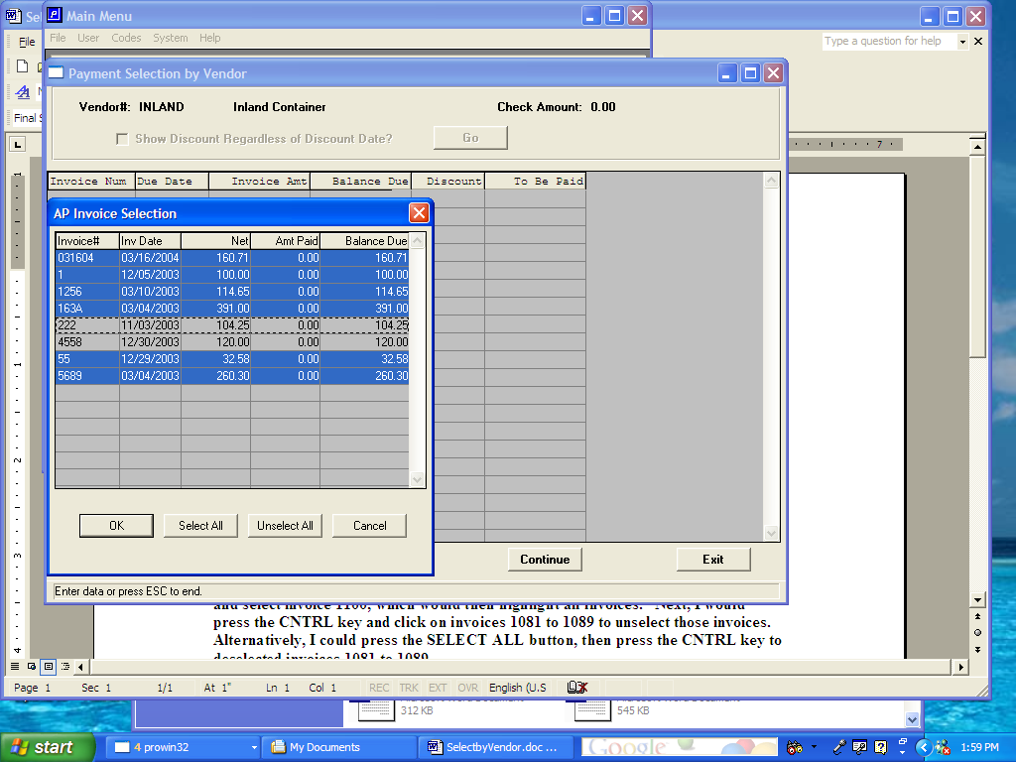

Vendor Invoice Selection Logic (March 22, 2004)

Vendor payment selection will now allow selecting invoices identical to Microsoft explorer or you may click the buttons at the bottom of the screen. The select all button will highlight all the invoices shown on the popup window. To eliminate a few invoices, simply press the CTRL key and click the appropriate invoices, which will deselect or un-highlight that invoice.

To select individual invoices, simply press the CTRL key and click the invoices paid, which will highlight those invoices. To pick a range of invoices, highlight the first invoice, then press the SHIFT key and click the last invoice number and the entire list will be highlighted.

For example, let’s assume that I wanted to selected all invoices except 222 and 4558. First, I would press the SHIFT key and highlight invoice 031604, then I would press the SHIFT key and select invoice 5689, which would then highlight all invoices. Next, I would press the CNTRL key and click invoices 222 and 4558 to unselect those invoices. Alternatively, I could press the SELECT ALL button, then press the CNTRL key to deselected invoices 222 and 4558.

